Controlled Shooting  Category: Technical: Shooting  Difficulty: Beginner | Barrington Area Soccer Association
shooting technique (10 mins)
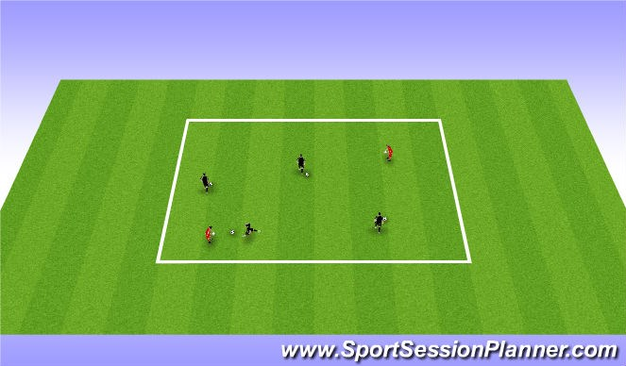
Shooting technique warm up
Have players dribble using their laces through out the grid.
Then challenge players to pick the ball up and punt strait in the air allowing the ball to bounce and restrike the ball right after
CP:
Players should be dribbling with their laces, and hitting the ball with their Laces in the air
(NO TOE!!)
Dribble to shoot gm1 (15 mins)
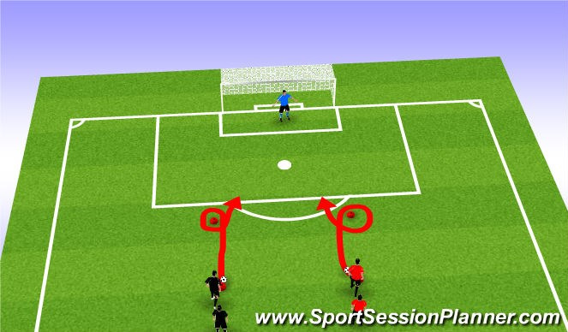
Players dribble down to the cone
cut around with the inside of foot (Right side uses Left foot, and
Left side uses Right foot)
Players race to score a goal. Winner gets a point
The when a team reaches "5" goals they rotate sides
Winning team is the first team to 10 goals CP:
Players must use laces to shoot the ball.
Land on Kicking foot.
Follow through the shot
Controlled dribble
Dribble to shoot GM2 (20 mins)
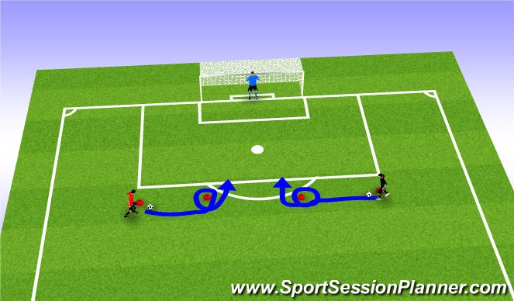
Players dribble to cone cut around the cone with the Outside of foot
(sweep cut)
Player sets his/her self up for a shot on goal.
Player should focus on striking the ball on goal and landning on kicking foot
Use both right and left foot. Left side uses left foot. Right side uses Right foot
The game is played which ever side gets to 5 goals first will switch sides and then use opposite foot. Encourage the players to use CP:
Shoot with laces
Strike through the ball and land on kicking foot Controlled dribble

1v1 Breakaway (20 mins)
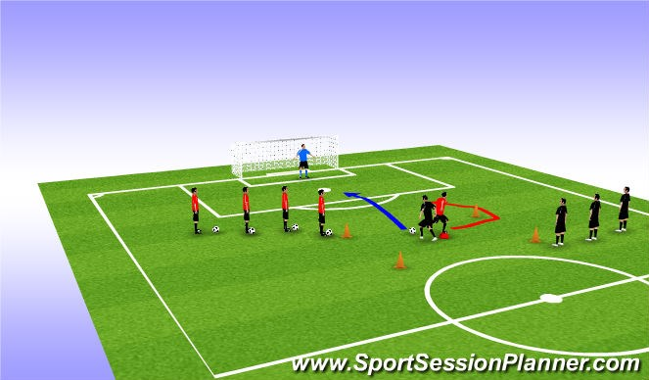
This is designed to have the players focus on contolled dribble and quick shooting
The red team starts with the ball and leaves it the small cone in the middle of the box, while continuing to run around the cone on the outside of the box and becomes the defender.
The black team takes the ball and dribbles to the goal.
CP:
Controlled dribble
Quick shot inside the 18 (big box)
Defender needs to recover with speed. Shoot with LACES

